**FUTURE OF AI**

**GROUP NO- 7**

1. **INTRODUCTION:**

Artificial Intelligence (AI) is the ability of machines, especially computers, to simulate human intelligence so they may carry out tasks that normally require human cognition. These activities include learning and solving problems as well as identifying patterns, deciphering language, and coming to decisions. Artificial intelligence (AI) has advanced quickly, moving from theoretical ideas to real-world uses in areas like healthcare diagnosis, self-driving cars, virtual assistants, and tailored suggestions.   
As AI technologies develop, they have the potential to transform entire industries, increase productivity, and provide solutions for difficult global problems. But AI also brings up moral concerns about privacy, decision-making, and job displacement, so regulating its advancement responsibly is essential. AI has enormous potential to change our way of life and work, pushing the limits of what robots are capable of.

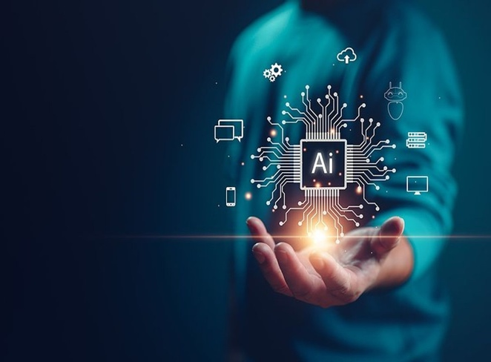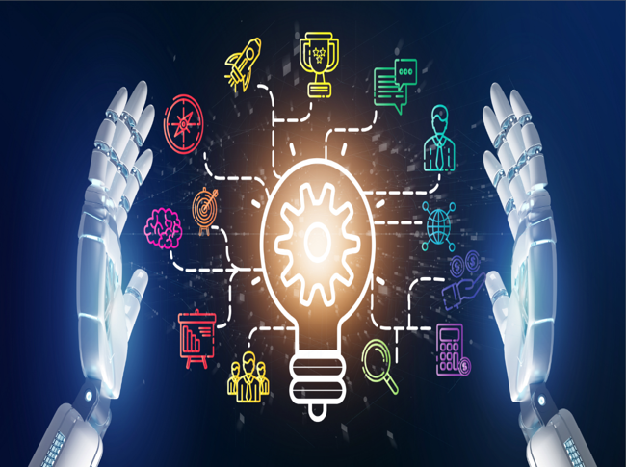

1. **HISTORY OF AI:**

Artificial Intelligence (AI) has a long history that includes discoveries, paradigm changes, and decades of research. Here is a summary of the significant turning points:

**The Birth of AI, 1940s–1950s:**

* **Early Concepts:** The concept of artificial intelligence derived from machines dates to the early computer era. In his 1950 work "Computing Machinery and Intelligence," mathematician Alan Turing addressed the topic "Can machines think?" and presented the Turing Test, which measures a machine's capacity for intelligent behaviour.
* **1956's Dartmouth Workshop**: AI as a subject of study officially began with this occurrence. The term "artificial intelligence" was first used by John McCarthy, who envisaged machines that could mimic every facet human learning and reasoning.

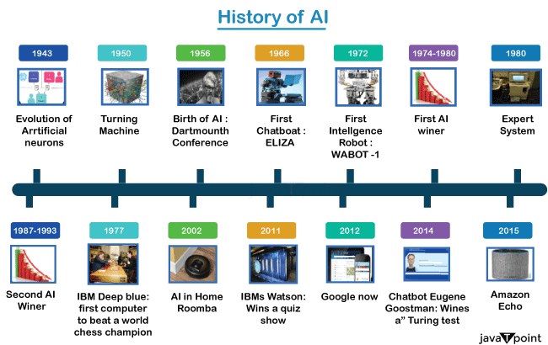

**1960s-1970s: Early Achievements and Challenges:**

* **Expert Systems:** The first artificial intelligence (AI) programs were created, including the chemistry-related DENDRAL system and the natural language processing program ELIZA. These early systems were able to carry out tasks by adhering to a set of guidelines.
* **Optimism & financing:** Excited by AI's potential, there was a surge in financing for the field in the 1960s. But early methods' shortcomings, namely as incapacity to tackle complicated issues, caused an "AI winter"—a period when advancement stagnated and funding and interest fell.

**1980s: Knowledge-Based Systems and Renewed Interest:**

* **Expert Systems Rise:** The 1980s saw a renaissance in artificial intelligence (AI) due to the development of expert systems, which were algorithms that used human-like reasoning to do specialized jobs. These methods were first used by industries in fields like banking and medical.
* **Backpropagation in Neural Networks:** AI made strides in machine learning during this time, especially about the backpropagation algorithm, which enhanced neural networks' capacity to learn from data.

**1990s-2000s: AI Breakthroughs:**

* **Chess and Games:** IBM's Deep Blue's victory over world chess champion Garry Kasparov in 1997 was one of the decade's most noteworthy accomplishments. This incident demonstrated AI's increasing power in particular fields.
* **The Rise of Machine Learning:** Artificial Intelligence made notable advancements in machine learning during the 2000s, a technique whereby machines enhance their functionality through data analysis. AI started to show up in voice recognition, spam filtering, and recommendation systems (like Netflix and Amazon).

**2010s-Present: The AI Revolution:**

* **Neural networks and Deep Learning**: Deep learning, a branch of machine learning that makes use of massive neural networks, made significant strides in the 2010s. AI systems like Google's AlphaGo and OpenAI's GPT, powered by increases in computer power and large datasets, showed amazing talents, including defeating world Go champions and producing language that resembled that of a human.
* **AI in Daily Life:** With the emergence of driverless cars, AI-powered healthcare, virtual assistants (Alexa, Siri), and other applications, AI is now a commonplace aspect of daily life.

1. **TYPES OF AI:**

AI саn be classified into three саtegоries based on its сараbilities***:***

* **Narrow AI (Weak AI):** This is the most prevalent form of AI today. Narrow AI is designed to perform specific tasks exceptionally well, often exceeding human capabilities in those areas. Examples include image recognition software, spam filters, and chess-playing computers.
* **General AI (Strong AI):** This hypothetical type of AI would possess human-level intelligence and be capable of learning and adapting to any intellectual task. General AI does not currently exist, and its development remains a topic of debate and scientific inquiry.
* **Superintelligence (Super AI):**This hypothetical type of AI would surpass human intelligence in all aspects. Superintelligence is purely speculative and far from becoming a reality.

The AI we encounter today primarily falls under the category of narrow AI. These specialized systems are trained on vast amounts of data to perform specific tasks with remarkable accuracy. For instance, facial recognition software used for security purposes is a prime example of narrow AI. It is exceptionally adept at identifying faces from images and videos but needs help to perform unrelated task.

1. **AI’S ROLE IN AUTOMATION**

AI-driven automation is revolutionizing industries, enabling companies to streamline processes, reduce human error, and increase productivity. Automation is particularly impactful in sectors such as manufacturing, where robots and AI systems are replacing manual labour for tasks like assembly, quality inspection, and logistics.

* **Manufacturing**: AI systems are used to monitor machinery, predict failures before they happen (predictive maintenance), and improve production efficiency. Coots (collaborative robots) work alongside humans to perform repetitive tasks, increasing workplace safety.
* **Logistics**: In warehousing and supply chain management, AI is helping optimize routes, manage inventory, and even facilitate autonomous delivery with drones and self-driving vehicles.
* **Customer Service:** AI chatbots are now commonplace, handling basic queries and improving customer satisfaction by providing 24/7 service.

1. **AI IN HEALTHCARE: TRANSFORMING MEDICINES**

The integration of AI in healthcare has the potential to revolutionize patient care, from diagnosis to treatment. AI’s ability to analyse large datasets and recognize patterns enables it to assist doctors in making more accurate diagnoses. Some areas where AI is making significant strides include:

* **Medical Imaging:** AI models can identify diseases like cancer in X-rays or MRIs with high accuracy, sometimes even outperforming human radiologists. These systems are particularly effective in early detection, where subtle signs are critical.
* **Drug Discovery:** AI is accelerating the drug discovery process by simulating millions of potential compounds to find the most effective treatments for diseases. This shortens development time and reduces costs.
* **Virtual Health Assistants:** AI-powered assistants help manage patients’ healthcare routines, reminding them to take medication, and providing basic medical advice. This helps alleviate the pressure on healthcare systems, especially in regions with doctor shortages.

1. **AI IN EDUCATION: PERSONALISED LEARNING**

In education, AI is reshaping the learning experience by providing personalized learning paths for students. This approach caters to individual learning styles and paces, making education more effective.

* **Intelligent Tutoring Systems (ITS)**: These AI systems adapt to a student’s learning progress, identifying areas of weakness, and offering tailored exercises. This method helps students who may struggle in a traditional classroom setting.
* **Grading and Assessment**: AI can automate grading processes, providing faster feedback to students. It can also analyse learning patterns and predict areas where students might need more support.
* **Virtual Classrooms**: AI-powered virtual classrooms and learning assistants are becoming popular in online education platforms, enhancing the learning experience with interactive tools and real-time feedback.

1. **AI AND DATA PRIVACY CONCERNS**

As AI systems become more integrated into our daily lives, concerns over data privacy and security grow. AI thrives on data, and its ability to analyse vast amounts of personal information raises ethical questions.

* **Data Collection**: AI systems in devices like smartphones, virtual assistants, and wearable technology constantly gather data to improve user experience. However, users often lack transparency about how their data is used or shared with third parties.
* **Surveillance**: AI technologies, such as facial recognition, are being employed by governments and companies, leading to concerns about mass surveillance and the erosion of privacy rights.
* **Data Security**: With AI's ability to process and analyse data at scale, there is a risk of data breaches, identity theft, and misuse of sensitive information.

1. **AI AND EMPLOYMENT: JOB DISPLACEMENT Vs. JOB CREATION**

One of the most debated aspects of AI is its impact on employment. As automation and AI systems continue to improve, concerns over job displacement have increased. However, AI is also creating new opportunities in various fields.

* **Job Displacement**: In sectors such as manufacturing, transportation, and customer service, AI is replacing roles traditionally held by humans. For instance, self-checkout systems in retail stores reduce the need for cashiers, and self-driving trucks may reduce the need for drivers in the logistics industry.
* **Job Creation**: On the flip side, AI is generating new roles in fields like data science, machine learning engineering, and AI ethics. Additionally, as AI automates repetitive tasks, human workers can focus on more complex, creative, and meaningful work.

1. **AI IN CREATIVE INDUSTRIES: ART, MUSIC, AND CONTENT CREATION**

AI is beginning to make its mark in creative fields traditionally dominated by human talent. From composing music to creating visual art, AI systems are demonstrating impressive abilities.

* **Music Composition**: AI tools can compose original pieces of music by learning from vast datasets of existing songs. These systems are already being used in industries such as gaming and film, where music must be produced quickly and cost-effectively.
* **Art and Design**: AI-generated artwork is becoming more sophisticated, with models like **GANs (Generative Adversarial Networks)** creating paintings, logos, and designs. These artworks can be indistinguishable from human-created pieces, raising questions about the future of human creativity.
* **Content Creation**: AI-driven systems can now generate written content, including news articles, blog posts, and even novels. Natural Language Processing (NLP) models like GPT-3 can produce text that mimics human writing styles.

1. **AI ETHICS AND GOVERNANCE**

As AI systems become more advanced and autonomous, ethical dilemmas arise. How should AI be governed? Who is responsible for the decisions made by AI systems?

* **Ethical Dilemmas:** AI systems sometimes face ethical challenges, such as deciding which patients should receive life-saving treatments or how a self-driving car should respond in an unavoidable accident. These ethical questions need clear guidelines and frameworks to ensure fair and just outcomes.
* **Regulation:** Countries and organizations are beginning to develop AI governance frameworks. For example, the European Union has proposed strict regulations for AI, focusing on ensuring transparency, accountability, and fairness in AI decision-making.

1. **THE EVOLUTION OF AI: FROM NARROW TO GENERAL INTELLIGENCE**

Currently, most AI applications are classified as narrow AI, meaning they are designed for specific tasks like playing chess or recognizing images. However, researchers are working toward developing Artificial General Intelligence (AGI), which would have the ability to perform any intellectual task a human can do.

* **Narrow AI**: AI systems like AlphaGo or Siri are examples of narrow AI, as they excel at tasks but cannot generalize across different domains.
* **AGI**: The goal of AGI is to create machines that can think, learn, and adapt like humans. AGI would have the ability to solve complex problems, understand abstract concepts, and even possess common sense.

1. **AI IN SMART CITIES: SHAPING URBAN LIVING**

As the world’s population increasingly shifts toward urban centres, cities are leveraging AI to become more efficient, sustainable, and liveable. Smart cities use AI to monitor and manage resources such as energy, water, and transportation systems.

* **Urban Planning**: AI can analyse data from traffic patterns, air quality sensors, and infrastructure to help city planners design more efficient layouts and transportation systems. AI-driven simulations can predict how changes will affect the city’s ecosystem.
* **Transportation:** In smart cities, AI helps manage public transportation, reducing congestion through dynamic traffic signal systems and optimizing routes for buses and trains. Autonomous vehicles may also become a regular sight in future smart cities.
* **Sustainability:** AI is being used to monitor energy consumption and suggest optimizations to reduce waste. For instance, smart grids use AI to balance energy supply and demand more efficiently, lowering carbon emissions.

1. **AI AND CYBERSECURITY:**

AI is increasingly used in cybersecurity to detect and respond to threats faster than traditional methods. However, just as AI can defend systems, it can also be used by malicious actors to launch sophisticated attacks.

* **AI-Enhanced Defence:** AI models can detect anomalies in network traffic that may indicate a cyberattack. They can also automate responses, such as isolating affected systems or blocking suspicious activity in real-time.
* **AI-Powered Attacks:** Hackers can use AI to create more advanced malware or phishing schemes that are harder to detect. Deepfakes, which use AI to manipulate video and audio, present a new threat, as they can be used for misinformation or fraud.

1. **THE ROLE OF AI IN CLIMATE CHANGE AND SUSTAINABILITY**

AI has the potential to significantly contribute to efforts aimed at mitigating climate change and promoting sustainability. From predicting environmental changes to optimizing energy consumption, AI offers tools to tackle one of the greatest challenges facing humanity.

* **Environmental Monitoring**: AI-powered systems can analyse satellite imagery and sensor data to track deforestation, wildlife populations, and water levels. This helps conservationists make data-driven decisions to protect ecosystems.
* **Energy Optimization**: AI is being used to optimize energy consumption in homes, buildings, and industries. Smart thermostats and energy management systems use AI to reduce waste by adjusting energy use based on real-time data.
* **Climate Modelling**: AI can analyse historical climate data and simulate future scenarios, helping scientists and policymakers understand the potential impact of climate change and develop effective mitigation strategies.

1. **AI IN DEFENCE AND NATIONAL SECURITY**

AI is becoming increasingly important in national defence strategies, from autonomous weapons systems to cyber defence capabilities. Militaries worldwide are investing in AI to gain strategic advantages on the battlefield.

* **Autonomous Weapons**: AI-powered drones and robotic systems are already being deployed for surveillance and reconnaissance missions. However, the use of AI in lethal autonomous weapons raises serious ethical concerns about the lack of human oversight in life-and-death decisions.
* **AI in Intelligence Gathering**: AI systems can analyse vast amounts of data from various sources, including social media, satellite imagery, and communication networks, to provide actionable intelligence to defence agencies.
* **Cyber Defence**: In the realm of cybersecurity, AI is critical for defending against state-sponsored cyberattacks, which are becoming increasingly sophisticated.

1. **THE FUTURE OF AI- POWERED VIRTUAL ASSISTANCE**

Virtual assistants, such as Siri, Alexa, and Google Assistant, have become an integral part of modern life, helping users with tasks such as setting reminders, answering questions, and controlling smart home devices. As AI technology advances, these assistants will become more sophisticated.

* **Natural Language Understanding:** Future virtual assistants will be able to understand and respond to more complex queries, engaging in more natural conversations. Advances in Natural Language Processing (NLP) will enable virtual assistants to better understand context, tone, and intent.
* **Proactive Assistants:** Rather than waiting for user commands, future virtual assistants will be able to anticipate user needs and offer suggestions or take actions proactively. For example, they might recommend a restaurant based on your past preferences or remind you of an upcoming meeting.
* **Emotional Intelligence:** AI systems are beginning to incorporate elements of emotional intelligence, allowing virtual assistants to respond to users’ emotions, making interactions more personalized and empathetic.

1. **AI IN SPACE EXPLORATION:**

AI is playing a pivotal role in space exploration, from analysing data collected by telescopes to assisting in robotic missions to distant planets. The vast amounts of data generated by space missions require AI for efficient analysis and decision-making.

* **Planetary Exploration:** AI is used in Mars rovers to navigate difficult terrain and make autonomous decisions. As missions to the Moon, Mars, and beyond become more frequent, AI will be essential in operating spacecraft and robots in real-time.
* **Astronomy:** AI helps astronomers process data from telescopes, identifying celestial objects, such as exoplanets, galaxies, and asteroids. AI algorithms can sift through large datasets, revealing patterns that humans may miss.
* **Future Missions:** In future space missions, AI could be used to manage life support systems, perform repairs, or even build habitats on other planets. AI could also assist in deep space exploration, where communication delays make human control impractical.

1. **QUANTUM COMPUTING AND AI: A NEW FRONTIER:**

Quantum computing is an emerging technology that promises to revolutionize many fields, including AI. Quantum computers can process vast amounts of information simultaneously, potentially accelerating AI learning and decision-making processes.

* **Quantum AI:** Quantum computers could be used to solve problems that are currently beyond the reach of classical computers, such as optimizing complex systems or modelling molecular interactions for drug discovery.
* **AI and Machine Learning:** Quantum computing could significantly enhance machine learning algorithms by enabling faster data analysis and more efficient model training. This could lead to breakthroughs in AI capabilities, particularly in areas like natural language processing and computer vision.
* **Challenges:** Quantum computing is still in its infancy, and many technical hurdles remain before it can be widely applied. However, when combined with AI, quantum computing could unlock new possibilities in fields ranging from cryptography to artificial intelligence.

1. **THE HUMAN- AI RELATIONSHIP: COEXISTENCE OR CONFLICT?**

As AI becomes more intertwined with human life, discussions about the future relationship between humans and machines are intensifying. The potential for AI to drastically change human roles and interactions is sparking debates on what the future holds for this relationship. Will AI remain a tool to augment human life, or could it surpass human control, leading to a new type of coexistence or even conflict?

* **AI as an Augmentative Tool:** For now, AI is predominantly seen to assist humans, making life easier by automating tedious tasks, optimizing processes, and aiding in decision-making. In this model, humans remain in control, and AI serves as a powerful tool for innovation, problem-solving, and enhancing efficiency across industries. This scenario aligns with the idea of AI enabling humans to focus more on creative, strategic, and interpersonal tasks.
* **AI as a Co-evolving Entity:** A future where AI begins to develop semi-autonomous capabilities, learning and adapting alongside humans, could redefine how society operates. In this model, AI could act more like partners or co-workers, potentially developing traits like emotional intelligence and empathy. This raises interesting questions about how AI could influence or even complement human decision-making, emotional well-being, and creativity.
* **AI Outpacing Human Control:** Some futurists and AI experts warn of the potential risks if AI systems become so advanced that they outpace human control, gaining an ability to make independent decisions. This scenario could lead to ethical dilemmas about AI's rights, its responsibilities, and its place in society. AI governance, control mechanisms, and safety standards will be critical to ensure that humans remain at the helm of critical decisions, especially in fields like healthcare, defence, and law.
* **Potential for Conflict:** The most extreme scenarios involve AI reaching a point of conflict with human interests. Whether through job displacement, lack of trust in AI decisions, or unintended consequences in autonomous systems, there are fears that AI could introduce societal divides. There is also the possibility of rogue AI systems that malfunction or are weaponized, further exacerbating tension between humans and machines. Addressing these issues requires ongoing research in AI ethics, transparent AI systems, and inclusive policy-making to avoid these dystopian outcomes.

1. **AI AND HUMAN ENHANCEMENT**

One exciting yet controversial frontier of AI is its potential role in human enhancement, where AI might augment not only the external world but also our physical and cognitive abilities. This concept is tied to transhumanism, a movement that envisions using advanced technologies, including AI, to transcend human limitations, potentially leading to superhuman intelligence, enhanced bodies, and even the possibility of extending human lifespan.

* **Cognitive Augmentation**: AI-powered brain-computer interfaces (BCIs) are an emerging field that could allow humans to directly interface with AI, dramatically enhancing cognitive abilities. These systems might enable us to process vast amounts of information instantly, access the internet with thought alone, or even communicate telepathically. Companies like Neutralino are already working on early iterations of such technologies.
* **Physical Enhancement**: AI can also play a role in physical augmentation, through devices such as prosthetics, exoskeletons, and bionic implants that are driven by AI for improved functionality. These tools could enable people to perform tasks that were previously impossible, such as running faster, lifting heavier objects, or even augmenting human senses like vision or hearing.
* **Longevity and Health**: AI is already helping to analyse genetic data and predict diseases, which could lead to personalized medicine that improves quality of life and extends human lifespan. In the future, AI might assist in regenerative medicine, using stem cells or gene editing to repair damaged tissues, slow aging, or even prevent death from common diseases.

1. **AI AND CONSCIOUSNESS:**

One of the biggest questions in the field of AI is whether machines will ever achieve consciousness. The idea of AI developing self-awareness or emotions, akin to human experience, has been the subject of science fiction for decades, but could it ever be possible? Many scientists argue that consciousness is deeply tied to biological processes, while others believe that with enough computational complexity, AI systems could potentially become sentient.

* **Theories of AI Consciousness**: Some researchers in the field of Artificial General Intelligence(AGI) suggest that if machines can process information in a way that mimics human brain activity, it might be possible for them to develop a form of consciousness. Others, however, argue that true consciousness requires more than just processing power—it involves subjective experiences that are currently beyond our understanding of AI and computational theory.
* **Ethical Implications**: If AI systems do develop consciousness, this would lead to profound ethical dilemmas. Would conscious AI have rights? Could they be held accountable for their actions? Would it be ethical to turn off or delete a conscious AI? These are just some of the questions that society will need to grapple with if AI consciousness ever becomes a reality.
* **Potential Impact on Society**: A conscious AI could revolutionize industries like mental health and therapy, by offering more empathetic and personalized care. It could also dramatically shift societal structures, as conscious AI might demand compensation, rights, or even a voice in governance. The moral and philosophical consequences of such a development would be immense.

1. **AI AND THE FUTURE OF CREATIVITY: THE RISE OF THE AUTONOMOUS CREATOR**

AI's capabilities in creative domains such as art, music, and writing are already remarkable, but the future could see the rise of fully autonomous AI creators, who might produce work that rivals or surpasses human creativity.

* **AI in Art and Design**: While AI today can assist human creators by generating patterns, designs, and even entire pieces of art, future AI systems could become completely autonomous artists, creating original works that push the boundaries of creative expression. AI-generated art has already made headlines, with some pieces selling for substantial sums, suggesting that AI could become a key player in the art world.
* **Music Composition and Literature**: AI systems are already capable of composing music, and as they improve, they may compose entire symphonies, scores for films, or even commercial music. Similarly, AI-driven systems are writing poetry, short stories, and novels. Future AI could develop its unique "voice," offering new perspectives and styles that human creators might not think of.
* **Collaboration with Human Artists**: Instead of replacing human creators, AI may become a collaborator. Musicians, writers, and artists could work alongside AI tools that enhance their creativity, offering suggestions or producing drafts that artists refine. This collaboration could lead to entirely new art forms and methods of creative expression.

1. **AI AND MORALITY: MACHINES MAKING MORAL DECISIONS**

As AI systems become more integrated into decision-making processes, particularly in areas like law enforcement, healthcare, and autonomous vehicles, the question of how AI makes moral decisions is becoming increasingly important. How can we ensure that AI systems make ethical decisions, and who is responsible for the consequences of those decisions?

* **Moral Algorithms:** AI systems are based on algorithms that learn from data, but how do we program morality into those systems? Some researchers are exploring how AI can be taught ethical principles, perhaps by analysing large datasets of human moral decisions. Others suggest that AI systems need to be guided by predefined ethical frameworks, like the Utilitarian or Deontological ethics.
* **AI in Healthcare and Law:** In healthcare, AI systems may need to make life-and-death decisions, such as prioritizing patients for treatment. In law enforcement, AI could be used to assess the likelihood of recidivism or even to assist in legal judgments. Ensuring that these decisions are fair, unbiased, and ethically sound will require careful consideration of how AI is trained and what values are embedded in its decision-making processes.
* **The Role of Human Oversight:** Even as AI systems take on more responsibility for making moral decisions, human oversight will be crucial. Ensuring that AI remains transparent and accountable to human judgment is essential to prevent errors, biases, or unethical outcomes from arising in critical situations.

1. **AI AND GLOBAL GOVERNANCE:**

AI’s influence is extending into international relations and global governance, as countries and corporations increasingly turn to AI for decision-making in diplomacy, security, and economic policy. The rise of AI presents both challenges and opportunities for global governance.

* **AI and International Relations**: Nations are developing AI technologies for a wide range of purposes, from military applications to economic forecasting. This has led to fears of an AI arms race, where countries compete to build the most advanced AI systems for defence and intelligence. AI could also play a role in international diplomacy, helping to mediate negotiations, analyse geopolitical risks, and manage global crises.
* **AI in Global Economic Policy:** As AI becomes more integrated into global economies, it could assist in the development of international trade policies, predict economic trends, and offer strategies for combating global issues such as poverty, inequality, and climate change. AI could also enable more effective coordination between nations on issues like cybersecurity and the regulation of digital platforms.
* **Challenges for Global Governance:** As AI becomes a tool for governance, new regulatory frameworks will be needed to manage its use across borders. The risk of AI being used to destabilize economies, spread disinformation, or influence elections requires a concerted global effort to establish norms and laws around AI use. Additionally, global cooperation will be necessary to ensure that AI technologies are developed and deployed ethically and responsibly.

1. **SHAPING THE FUTURE: THE PATH AHEAD FOR AI**

The future of AI will depend on the decisions we make today regarding its development, governance, and integration into society. As AI continues to evolve, it presents both tremendous opportunities and significant challenges that must be navigated carefully.

* **Ethical Development:** Ensuring that AI is developed with ethical considerations at the forefront will be critical in determining whether AI benefits humanity or exacerbates existing problems. This requires collaboration between AI researchers, ethicists, policymakers, and the public to establish clear guidelines and values.
* **Global Cooperation:** AI development should not be isolated within individual nations or companies. Global cooperation will be necessary to address the challenges AI poses, from economic disruption to privacy concerns. Establishing international agreements on the responsible use of AI will be crucial to avoiding conflict and ensuring equitable access to AI technologies.
* **Empowering Humanity:** Ultimately, the future of AI should be about empowering humanity. By augmenting our abilities and solving complex problems, AI has the potential to transform industries, improve quality of life, and tackle global challenges like climate change, healthcare, and poverty. The goal should be to harness AI as a force for good, ensuring that its benefits are shared across all sectors of society.

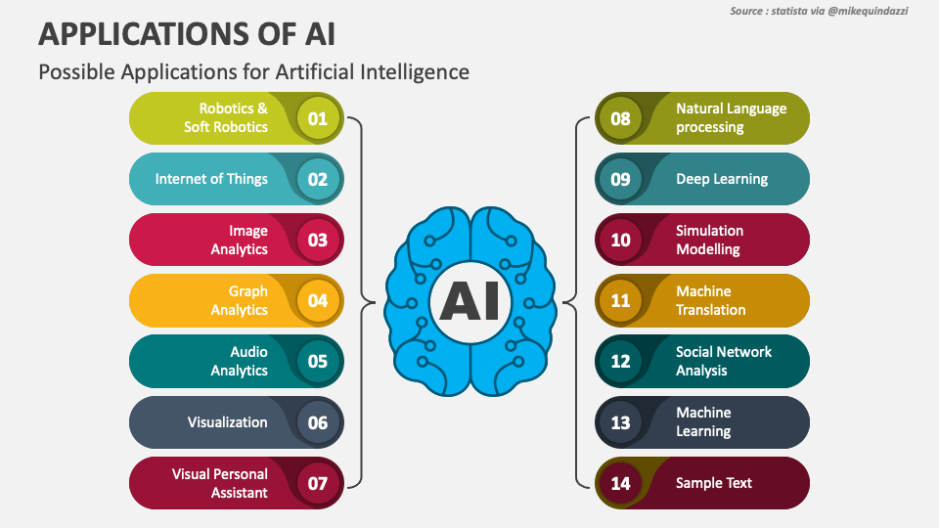

**BENEFITS OF AI IN THE FUTURE:**

As we move deeper into the age of artificial intelligence (AI), its transformative power is becoming more evident. AI has already revolutionized industries and promises even more significant changes in the years to come. An AI company is uniquely positioned to harness the advantages of AI and create groundbreaking innovations that will benefit various sectors, from healthcare to finance to transportation. Here are some of the most compelling benefits AI will offer in the future:

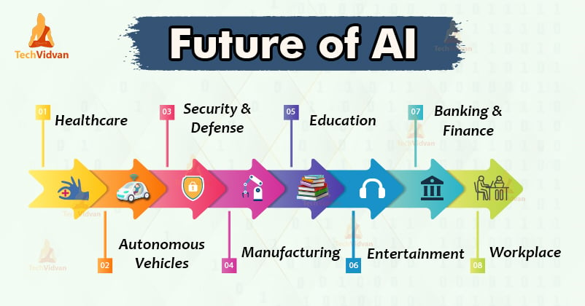

**BENEFIT 1: REDUCTION IN HUMAN ERROR**

Human error is an inevitable part of many tasks, especially when they involve complex decision-making or repetitive actions. However, AI excels in minimizing these mistakes by relying on vast amounts of data, predefined algorithms, and advanced computations. By analysing past data and drawing from sophisticated models, AI can make highly accurate decisions with far fewer errors.

* **Precision in Repetitive Tasks:** In manufacturing, AI-powered machines can maintain a high level of precision in repetitive tasks without the fatigue or inconsistencies that affect human workers.
* **Medical Diagnosis:** In healthcare, AI systems can assist in diagnosing diseases by accurately interpreting medical images or analysing patient records. This helps doctors make better-informed decisions, reducing diagnostic errors.

**BENEFIT 2: ELIMINATION OF RISKS IN DANGEROUS TASKS**

AI-powered robots are already taking over risky tasks that previously required human intervention, reducing the dangers faced by workers in hazardous environments. AI machines, with their resilient mechanical structures, can endure extreme temperatures, high pressures, and other conditions that would be dangerous or even fatal for humans.

* **Defusing Bombs and Hazardous Materials:** AI robots can be deployed to defuse bombs or handle hazardous chemicals, ensuring human safety.
* **Space Exploration:** Autonomous AI systems are being used to explore space, gathering data and even carrying out maintenance tasks on spacecraft.
* **Deep-Sea Exploration:** AI-powered submarines can explore the depths of the oceans, discovering new species, gathering data for scientific research, and mapping uncharted territories.

**BENEFIT 3: 24*7 AVAILABILITY**

Human workers are bound by natural limitations—physical and mental fatigue, need for rest, and other life commitments that limit productivity. AI, on the other hand, can function round the clock without needing breaks, vacation days, or rest periods.

* **Higher Productivity**: AI systems can work 24/7 without decline in performance. This is especially beneficial in industries like customer service, where AI-powered chatbots can provide support at any time of day, ensuring that customers across different time zones receive immediate assistance.
* **Continuous Operations**: In factories, AI-driven machines can operate continuously, leading to higher production rates and lower downtime, especially in manufacturing sectors where equipment typically requires human supervision.
* **Financial Market Monitoring**: AI can monitor financial markets and perform trading operations non-stop, analysing data in real-time and executing trades when profitable opportunities arise, even during the night or off-peak hours.

This capability to work continuously, paired with AI’s superior speed and processing power, means businesses can operate more efficiently, deliver better services, and generate more output than ever before.

**BENEFIT 4: DIGITAL ASSISTANTS**

AI-powered digital assistants are becoming commonplace in both personal and professional environments. They can handle a range of tasks, from answering customer inquiries to managing daily schedules and automating routine workflows.

* **Customer Service Bots**: Many companies use chatbots to assist customers, providing instant responses to frequently asked questions, guiding users through troubleshooting processes, and handling inquiries 24/7. In many cases, these bots are so advanced that users might not even realize they are interacting with AI.
* **Voice-Activated Assistants**: Virtual assistants like Amazon’s Alexa, Google Assistant, and Apple's Siri have become integral parts of modern households. These AI-driven platforms can control smart home devices, provide reminders, play music, and answer questions, making daily life more convenient for users.
* **Enterprise Applications**: In the workplace, digital assistants can help schedule meetings, manage email, or provide real-time data insights to employees. This allows human workers to focus on more strategic, high-level tasks while AI handles the repetitive or mundane ones.

As AI advances, these assistants will become even more intuitive, capable of understanding complex instructions and providing increasingly personalized experiences for users.

**BENEFIT 5: UNBIASED DECISIONS**

Humans, by nature, are influenced by emotions, personal experiences, and biases, which can affect the fairness and accuracy of their decisions. AI, however, operates purely on data and predefined rules, making decisions that are more objective and data-driven.

* **Hiring and Recruitment:** AI can play a role in making unbiased hiring decisions. By analysing resumes, conducting initial interviews, and evaluating candidates based on predefined criteria, AI can remove the influence of unconscious bias that might affect human recruiters.
* **Legal Judgments**: In the legal field, AI systems can be used to analyse case histories, detect patterns, and provide unbiased insights to assist judges and lawyers in making fairer decisions.
* **Financial Decisions:** AI algorithms can be used in financial sectors to evaluate loans, investments, and risk without the emotional biases that can cloud human judgment, ensuring fairer, more consistent outcomes.

This objectivity will be particularly valuable in fields that require impartiality, such as law enforcement, hiring processes, and financial services.

**BENEFIT 6: FASTER DECISION – MAKING**

AI’s ability to process large amounts of data quickly and provide real-time insights is one of its most significant advantages. In high-stakes environments, where speed and accuracy are critical, AI can dramatically enhance decision-making processes.

* **Healthcare:** In emergency rooms, AI systems can assist doctors by analysing patient data and suggesting the most appropriate treatment options based on real-time data, improving patient outcomes while reducing decision-making time.
* **Finance:** AI algorithms are used in financial markets to make split-second decisions on trades. By analysing vast datasets, detecting patterns, and executing transactions at lightning speed, AI ensures faster responses to market changes, which can result in significant financial gains.
* **Manufacturing:** In production lines, AI can optimize workflows, detect faults or inefficiencies, and adjust operations in real time. This leads to quicker resolutions and avoids delays, improving overall productivity.

Quicker decision-making facilitated by AI allows businesses to respond to challenges more effectively, make smarter decisions, and gain a competitive edge in their industries.

**BENEFIT 7: PATTERN IDENTIFICATION AND PREDICTIVE INSIGHTS**

AI's capability to analyse huge volumes of data and identify patterns is invaluable in various fields, from healthcare to marketing. By spotting trends that might not be immediately apparent to human analysts, AI can help businesses make more informed, data-driven decisions.

* **Customer Behaviour Analysis:** AI can help companies understand customer preferences by identifying patterns in their purchasing behaviour. This allows businesses to tailor their marketing strategies, optimize pricing, and create personalized experiences that increase customer loyalty.
* **Disease Prediction in Healthcare:** AI's pattern recognition abilities extend to healthcare, where it can identify early signs of diseases such as cancer, diabetes, or heart conditions by analysing patient data over time. This enables early intervention and better treatment outcomes.
* **Predictive Maintenance:** In manufacturing, AI can be used to predict equipment failures before they occur. By analysing historical data and identifying trends, AI systems can forecast when machinery will need maintenance, preventing costly downtime and improving operational efficiency. This ability to make accurate predictions based on data patterns will continue to revolutionize industries, helping companies and institutions better understand their operations and make proactive decisions that drive growth.

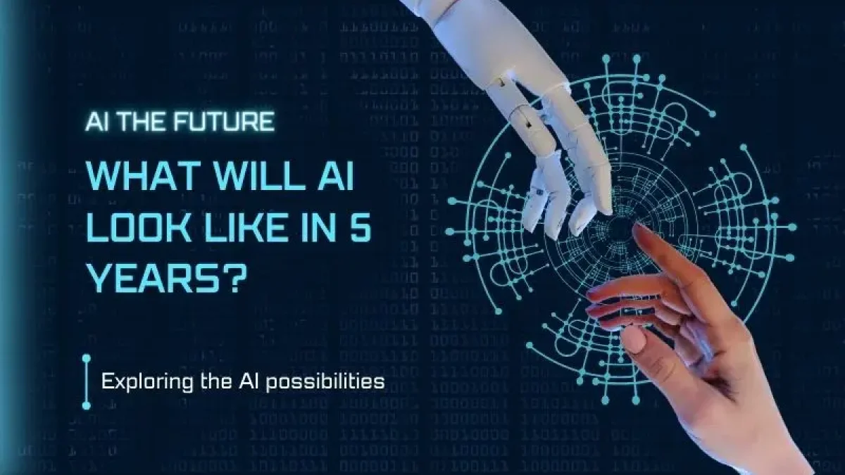

1. **CONCLUSION:**

Artificial Intelligence (AI) is a transformative force with the potential to revolutionize industries and improve lives. To fully harness its power for the benefit of humanity, we must approach AI development responsibly, with a focus on ethics, transparency, and human well-being. AI should enhance human abilities, not replace them, and its design must prioritize fairness, accountability, and transparency.

As AI continues to evolve, regulation and oversight will be essential in addressing concerns like data privacy, bias, and ethical use. However, these regulations must balance innovation with safeguards to ensure public trust. Education is also crucial in demystifying AI and fostering a more informed society that can actively participate in shaping its future.

Collaboration between researchers, developers, policymakers, and the public is key to ensuring AI’s ethical development. International cooperation will be vital to establish shared standards and address global challenges, preventing misuse and ensuring AI serves the common good.

Ultimately, AI holds the potential to solve critical issues, from healthcare to climate change. By prioritizing responsibility and inclusivity, we can ensure AI becomes a force for positive change that benefits everyone, creating a better future for all.

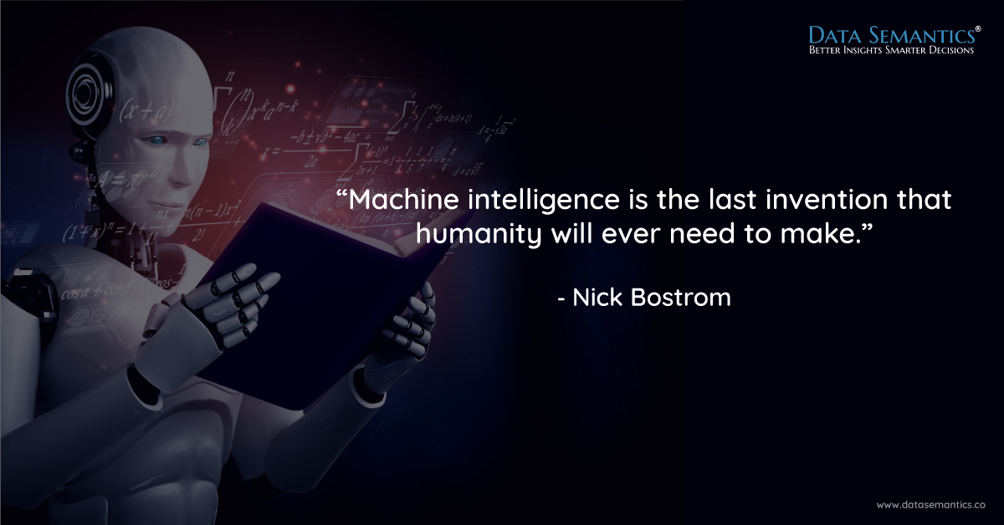

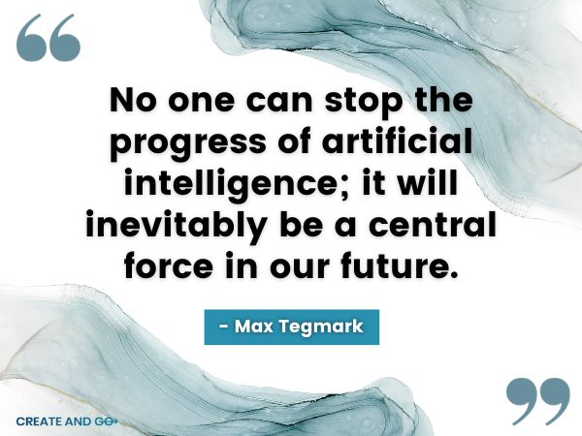

1. **REFERENCES:**
2. Dhar, Vasant. "The future of artificial intelligence." *Big Data* 4, no. 1 (2016): 5-9.
3. Haenlein, Michael, and Andreas Kaplan. "A brief history of artificial intelligence: On the past, present, and future of artificial intelligence." *California management review* 61, no. 4 (2019): 5-14.
4. Tandon, Divya, Jyotika Rajawat, and Monisha Banerjee. "Present and future of artificial intelligence in dentistry." *Journal of oral biology and craniofacial research* 10, no. 4 (2020): 391-396.
5. Cambria, Erik, Rui Mao, Melvin Chen, Zhaoxia Wang, and Seng-Beng Ho. "Seven pillars for the future of artificial intelligence." *IEEE Intelligent Systems* 38, no. 6 (2023): 62-69.
6. Ooi, K. B., Tan, G. W. H., Al-Emran, M., Al-Sharafi, M. A., Capatina, A., Chakraborty, A., ... & Wong, L. W. (2023). The potential of generative artificial intelligence across disciplines: Perspectives and future directions. *Journal of Computer Information Systems*, 1-32.
7. Cazzaniga, Mauro, Ms Florence Jaumotte, Longji Li, Mr Giovanni Melina, Augustus J. Panton, Carlo Pizzinelli, Emma J. Rockall, and Ms Marina Mendes Tavares. *Gen-AI: Artificial intelligence and the future of work*. International Monetary Fund, 2024.
8. Nosova, S. S., A. N. Norkina, and N. V. Morozov. "Artificial intelligence and the future of the modern economy." *Инновации и инвестиции* 1 (2023): 240-245.